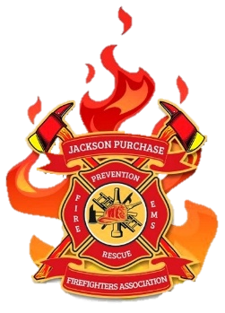JACKSON PURCHASE 2026 FIRE SCHOOL
MARCH 27-29, 2026
JACKSON PURCHASE 2026 FIRE SCHOOL booklet.docx
WKCTC Emerging Technology Center
4810 Alben Barkley Drive
Paducah, KY 42001
Building #14
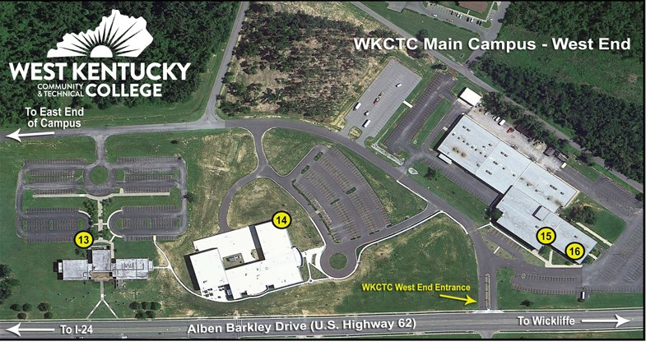

2026 Fire School Classes
Class # | Class Name | Day | Credit Hrs. | Code
F-001 | Basic Firefighter | Fri/Sat/Sun | 20 | Various
F-002 | Fire Tactics | Sat/Sun | 16 | M0001
F-003 | EV Fires | Sat | 8 | M0002
F-004 | Grain Bin Rescue | Fri/Sat/Sun | 20 | Q0006
F-005 | Thermography/Fire Box | Sat or Sun | 16 | D0000
F-006 | Hard to Get Hours | Sat/Sun | 16 | M0001
F-007 | Haz Mat Awareness | Sat | 8 | T0001
F-008 | Haz Mat Operations | Sun | 8 | Y0002
F-009 | Extrication | Sat/Sun | 16 | Q0001
F-010 | Pumper Ops/Water Supply | Sat | 16 | Z0000
F-011 | Basic Fire Chaplain | Fri/Sat | 12 | JJ0000
F-012 | Fire Chaplain Advance | Sun | 8 | JJ0000

F-001 – Basic Firefighter (Boots, Hose and Grit: Mastering the Basics) 20 Hours
THIS CLASS IS ON FRIDAY, SATURDAY, and SUNDAY
This class will explore the basic skills every firefighter needs to know. This class will benefit new firefighters as well as seasoned veterans. The subjects taught will follow the Kentucky Fire Commission’s recommended initial 20-hour list. Subjects will include:
administration & organization , safety, fire behavior, extinguishers,
personal protective equipment, forcible entry, ventilation, ropes,
ladders , fire hose, nozzles & appliances, fire control, loss control,
driver training.

F-002 – Fire Tactics-16 Hours
What are the best fireground tactics and techniques? They include conducting a thorough size-up, prioritizing life safety, utilizing a "buddy system", employing a direct attack at the base of the fire, properly ventilating the structure, performing a primary search quickly, strategically deploying hose lines, and adapting operations based on fire behavior and building construction, all while maintaining constant communication and awareness of potential hazards.

F-003 – EV Fires (Shock & Flame: Battling EV Blazes) 8 Hours
This comprehensive training course is designed to educate first responders, firefighters, safety personnel, and industry professionals on the unique challenges and hazards associated with electric vehicle (EV) fires. Participants will gain a thorough understanding of EV battery technology, fire behavior, and the safest and most effective response strategies.

F-004 Grain Bin Rescue (Seconds from Suffocation) 20 Hours
This specialized course is designed to prepare firefighters, first responders, and emergency personnel for effective and safe response to grain bin and agricultural entrapment incidents. Participants will gain the knowledge and hands-on skills necessary to recognize hazards, implement rescue strategies, and operate within an incident command structure during grain-related emergencies. This course emphasizes practical, real-world applications with hands-on evolutions using rescue tubes, augers, lockout/tagout procedures, and patient packaging systems. Participants will leave with enhanced skills to improve survivability rates during these complex rescue operations.

F-005 – Thermography/Fire Box 8 Hours
Have you ever been handed a Thermal Imaging Camera and the had the “nickel tour” or “5 minute” lesson on it? JPFA has sought to remedy as many questions as answers could be provided for this field of expertise. May vendors are great about selling a department the latest and greatest Thermal Imaging Devices and they often provide instructions on the day of delivery. Definitely not on your training night, correct? So, it is up to the Chief to get your training, let’s fix that. No disrespect to any Chief for their attempt to pass along the knowledge shared by the vendor, but the vendor or Chief might have forgotten to share something along the way. Whether it’s on our SCBA, regulators or handheld, we want you to understand as many more features or abilities as possible as these are part of your “tools of the trade”. JPFA has looked to State Fire & Rescue Training to provide an instructor with the answers.

F-006 – Hard To Get -16 Hours
This class is ideal for the firefighter that is almost certified but lacks
just a few needed hours that are “hard to get”.
This two-day class will offer the following course topics:
Emergency & Disaster Planning, Communications, Fire Investigation,
Fire Protection Systems, Aircraft, Fire Extinguishers.

F-007 – HazMat Awareness-8 Hours (Sat)
The Hazardous Materials Awareness level course is for personnel that
may encounter a hazardous materials incident in the scope of
their normal duties. Personnel trained to this level should be able to:
Analyze an incident to detect the presence of hazardous materials,
identify/collect information from the Emergency Response
Guidebook, and initiate protective actions/notification
process.
F-008 – HazMat Operations-8 Hours (Sun)
The Hazardous Materials Operations course is designed for those that would respond to a hazardous materials incident and implement or support the response mission. Some of the topics covered in this class include:
- Analysis of the scene, determination of the scope of the emergency,
- collection of information
- prediction of the likely behavior and potential harm from the hazardous material
- planning of the response
- selection of the correct level of personal protective equipment

F-009 – Extrication- 16 Hours
One of the most common technical rescue scenarios that the fire service deals with vehicle rescue/extrication. This subcategory is intended for training that includes extrication from both light and heavy vehicles.
Examples of topics for this category include, but are not limited to:
1 Methods for removing vehicle glass
2. Removal of automotive window glass
3. Vehicle roof posts and their letter designations
4. Removal of vehicle doors
5. Removal of vehicle roofs

F-010 – Pumper Ops/Water Supply-16 Hours
Firefighters need to be trained to operate the pumping apparatus, as operated by their fire department. Personnel should be trained in the daily, weekly, or monthly maintenance needed for the pumping apparatus. Training shall be consistent with the latest edition of job performance requirements of NFPA 1002 “Standard for Fire Apparatus Driver/Operator Professional Qualifications
Many factors make up water supply training, including how much water flow is necessary for fire suppression on a structure based on the dimension of the structure. Topics and considerations include where the closest water resources are, shuttle operations (water haul), pumper relay operations and the amount of water flow available from a hydrant.

F-011 Fire Chaplain (Basic Class) 12 Hour Class
4hrs-Friday, 8hrs- Saturday
The Basic Fire Chaplain Training includes 1 ½ day of course material
designed to introduce the fire chaplain to ministry in the fire service. The
materials in this course will provide information that will lay a good
foundation for the fire chaplain to be able to assist fire departments in
times of spiritual and emotional trauma and/or crisis. Topics included are
the following:
- roles of fire chaplains
- how to minister to firefighters
- how to minister to fire victims
- critical incident stress
- fire department funerals
- basic fire chaplain operations
Successful completion of this class will partially fulfill the training requirements necessary to become a certified chaplain by the Kentucky Fire Commission. This course also serves as a great annual refresher for all fire chaplains.

F-012 Fire Chaplain (Advanced Class) 8 Hour Class (Sunday)
Funeral Preparation and Grief Counseling
Note: You do not have to have had the Basic Chaplain Class to take this 8 hour class.
Advanced Chaplain classes are classes expanding the knowledge bases of the basic course. There are a variety of classes taught that are classified in the Advanced Level of Chaplain program to assist the chaplain in their growth as a minister. This course is designed to equipe chaplains with the tools to be able to assist with the following:
- death notifications
- plan a funeral for a non-LODD
- plan a funeral for a LODD
- how to interact with a grieving family
- how to prepare, craft & deliver a funeral message

2026 Spring Fire School Registration
JPFA Members $75.00 per student
Non JPFA Members $85.00 per student
Free t-shirt when registered by March 1, 2026.
T-shirts will be available for purchase for $25.

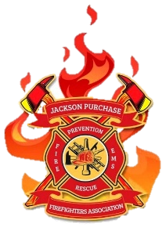
2026 Spring Fire School Registration

Name:

Home Address

City

County

State

Zip Code

Phone

Email

Fire Department

Fire Department Email

KY State Firefighter #

Shirt Size

Class Selection
Friday Class Choice

Saturday Class 1st Choice

Saturday Class 2nd Choice

Sunday Class 1st Choice

Sunday Class 2nd Choice

Send Registration to:

Jackson Purchase Firefighters Association
PO Box 307 Mayfield, KY 42066

Email: d.jackson1274@gmail.com

Hotels in the Area

Hampton Inn & Suites Paducah

3901 Coleman Crossing Cir, Paducah, KY 42001

(270) 442-0220

Country Inn & Suites by Radisson, Paducah, KY

145 McBride Ln, Paducah, KY 42001

(270) 442-2201

Courtyard by Marriott Paducah

3835 Technology Dr, Paducah, KY 42001

(270) 953-7501
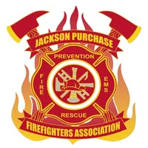
Jackson Purchase Firefighters Association
Office of the President
Kenney M. Etherton
Dear Firefighters, Emergency Services Personnel, and Valued Vendors,
On behalf of the Jackson Purchase Firefighters Association (JPFA), it is my honor and privilege to welcome you to the 2026 JPF Spring Fire School. We are proud to once again bring together the dedicated men and women who serve our communities with courage, skill, and selfless commitment.
This annual event stands as a cornerstone of our mission—to promote professional excellence, enhance safety, and strengthen the bonds within our firefighting and emergency services family. Over the coming days, you will have the opportunity to participate in hands-on training sessions, dynamic workshops, and valuable networking opportunities with colleagues from across the region and beyond.
To our firefighters and emergency personnel, thank you for your unwavering service and your commitment to continual improvement. The knowledge and experience you gain here not only enhance your own capabilities but also contribute to the safety and well-being of the citizens we serve.
To our vendors and sponsors, your continued partnership is invaluable. Your support helps make this training possible and ensures that our firefighters have access to the best equipment, technology, and innovations available in the field today.
As we gather for the 2026 JPFA Training, let us celebrate our shared mission, renew our dedication to excellence, and continue to learn, lead, and serve with pride.
Thank you for being part of this important event. I look forward to a successful and inspiring weekend of training for all.
With warm regards,
Kenney
Kenney M. Etherton
President Jackson Purchase Firefighters Association
